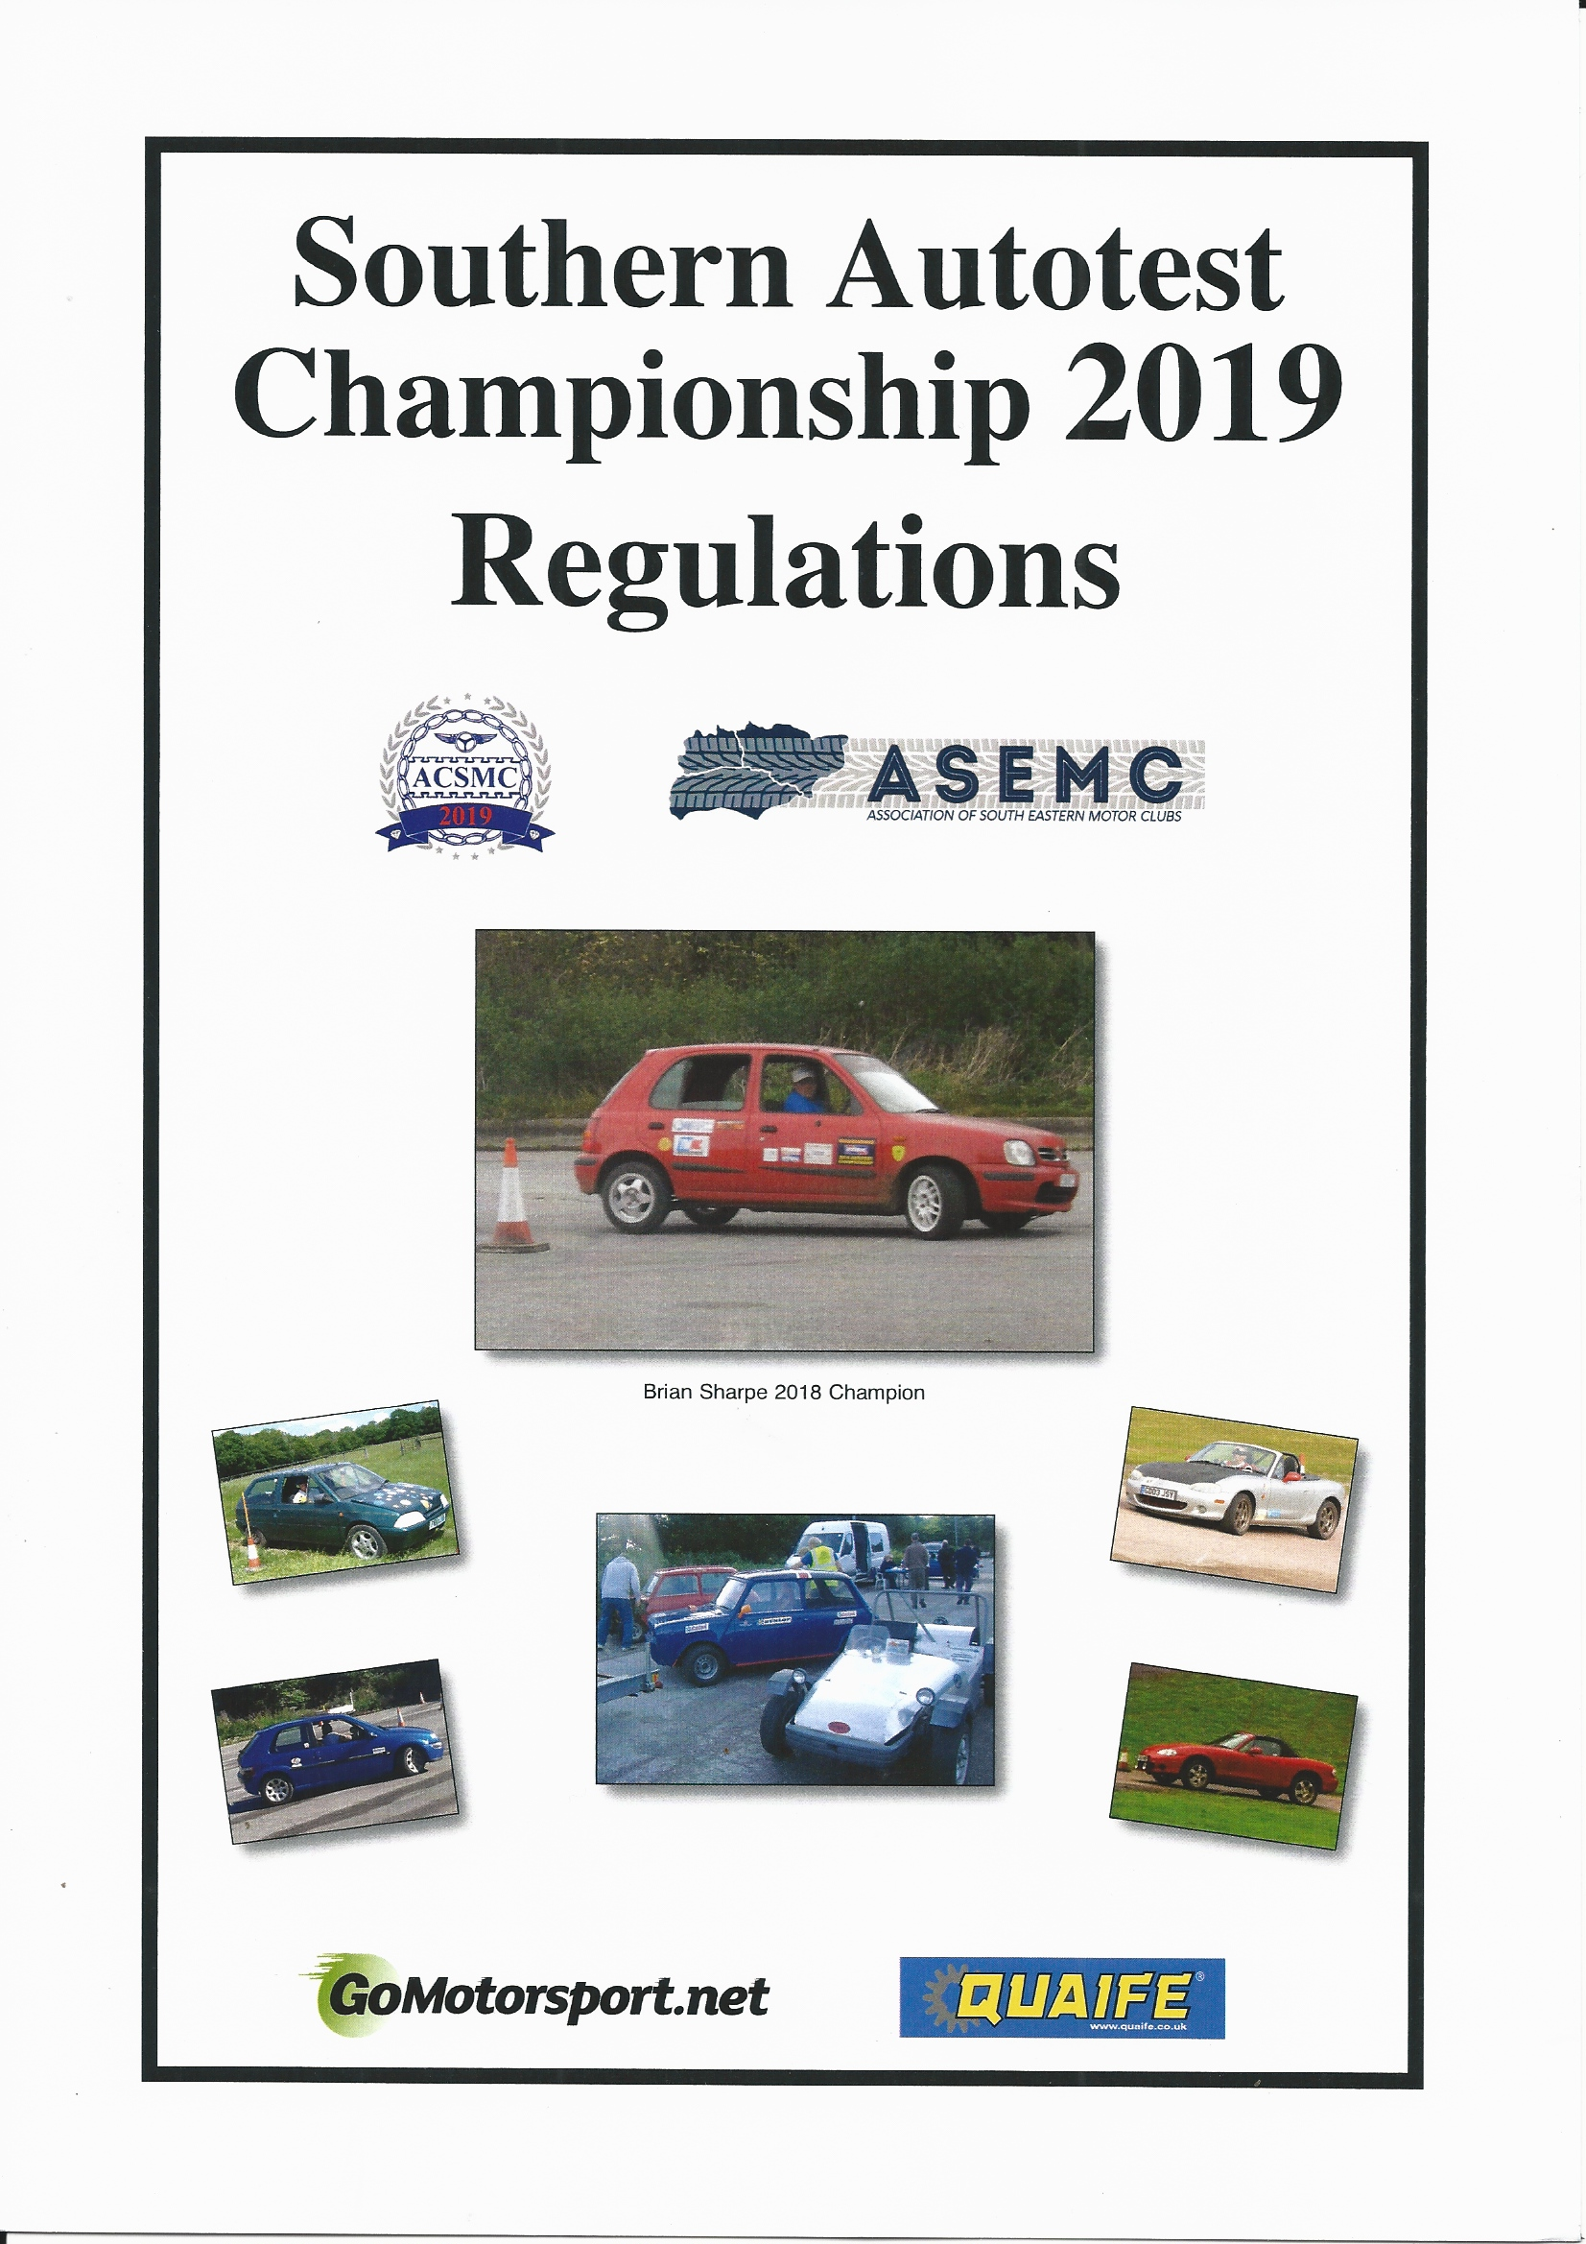
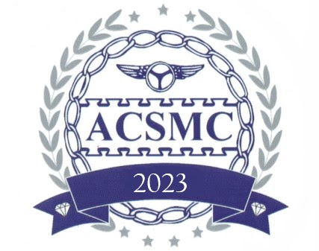
SOUTHERN AUTOTEST CHAMPIONSHIP 2023
ENTRY FORM

I wish to participate in, and register for, the SOUTHERN Autotest Championship. I agree to be bound by the Championship Regulations. I have no objection to the following details being held on a computer database.

Surname: ………………………………First Name:……………………………………………….

Address: ………………………………………………………………………………………………

…………………………………………………………………………………………………………

……………………………………………………………..…………………………………………

Tel. No. (Home): ................................................... (Mobile):....................................................

Email : ……………………………………………………………………………….

I am a member of the following ACSMC or ASEMC motor club:

...........................................................................

Motorsport UK Licence number …………………

The RS Clubman licence is available free of charge from https://rsclubman.motorsportuk.org

I intend to compete in Class:………......... (See below for championship classes)

A. Front wheel drive Touring Cars up to and including 3.66m (12ft) overall length.
B. Front wheel drive Touring Cars over 3.66m (12ft) overall length and under 4.1m (13ft 5¾in)
C. Front wheel drive Touring Cars over 4.1m (13ft 5¾in) overall length
D . Rear wheel drive Touring Cars
E. Sports and Sports Kit Cars (including cabriolets running with the hood own).
F . Specials (Two wheel drive only).

Make of Car: ........................... Model:.......................................... Capacity:………….

My car is eligible for Road going Award (taxed and insured) YES / NO

I am eligible for the U25 award YES / NO

I am eligible to compete for: The Novice Award YES / NO (not won a 1st in class on a Clubman or higher event
more than twice where the entry in the class
was more than 2.)

Return to: Peter Cox, 19A Oxford Street, Lambourn, Berks. RG17 8XS
or by email to peter@the-coxes.com

